**DevOps Architecture for intergalactic cookie oven**

Microservice adaption: Let’s adopt microservices for the production deployment of all endpoints. Every task or component will be a microservice which will be capable of building and deploying irrespective of other services. In this way, we will reduce downtime during deployments and any bad code or configuration in one particular service will not take down the whole application.

**Building and Deploying all components:**

1. Dockerizing Micro-Services: Once we have code available, we will dockerize every service and will store the docker image to a secure private repo ( it could be either private docker-hub repo or AWS ECR).
2. The above mentioned task 1 will be taken care of by any build automation tool like Jenkins. Jenkins or CI tool will take care of the running tests as well as part of CI process.
3. Once the CI part is complete, the CD part will be triggered where we will deploy the above mentioned services using Kubernetes on multiple hosts and using multiple replicas.
4. We will expose our web or frontend part of deployment using Elastic Load Balancers. SSL termination will take place at LoadBalancer level to ensure traffic in is encrypted.

This is how the application access will work for customers ( end-users ) perspective  
  
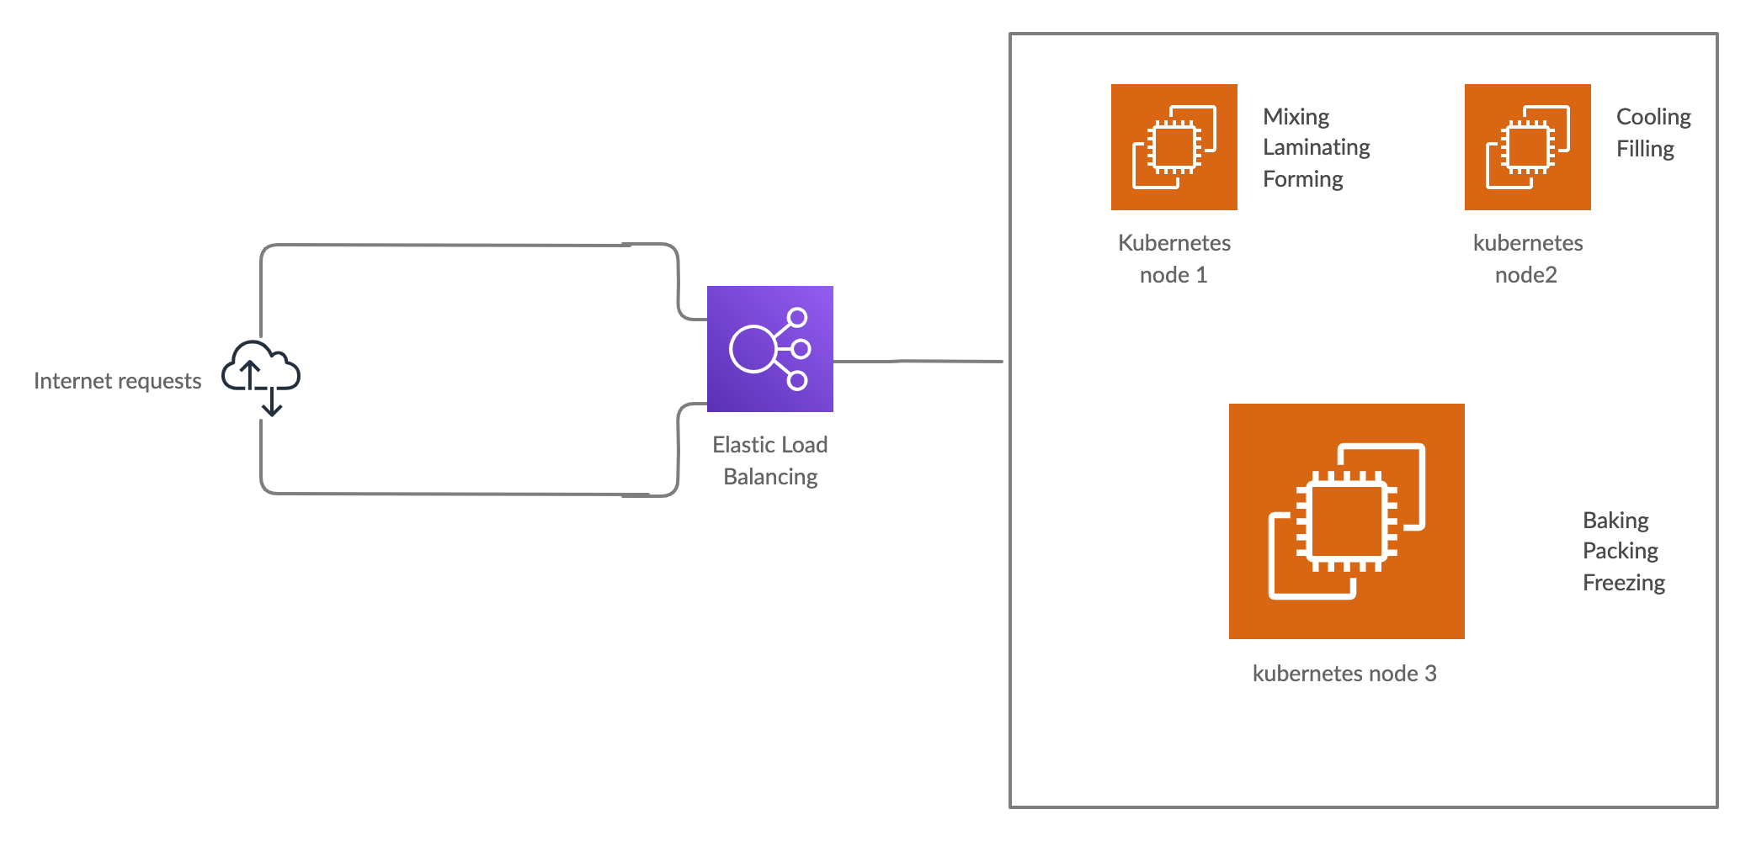

This is how network diagram will look for deployments/devops team perspective

